INVENTION DISCLOSURE FORM
Invention disclosure No. | Title of the invention
System and Method for Bounded Diff-Aware Self-Healing Software Application Delivery
(Working title of the prototype: “ForgeFlow”)
Applicant Name | Symbiosis International (Deemed University)
If Joint Applicant collaboration with (Joint Applicant Name) | Not applicable; no joint applicant.
Name of the inventor (s) | Inventor(s) Institute & Department Name
1. Mr. Faheemuddin Sayyed  2. Mr. Sanidhya Awasthi  3. Mr. Raghav Sonchhatra  4. Dr. Payal Kadam | Inventors 1–3 (Mr. Faheemuddin Sayyed, Mr. Sanidhya Awasthi, Mr. Raghav Sonchhatra): B.Tech (CSE) students.  Inventor 4 (Dr. Payal Kadam): Faculty member of the same Department.  All four inventors: Dept. of Computer Science & Engineering,  Symbiosis Institute of Technology (SIT),  Symbiosis International (Deemed University),  Lavale, Pune 412115, Maharashtra, India.
Email address & Phone number of the inventor (s) | Faheemuddin Sayyed: faheemuddinsayyed789@gmail.com | Phone: +91 9356763651  Sanidhya Awasthi: sanidhya.awasthi19@gmail.com | Phone: +91 9023982865  Raghav Sonchhatra: rsonchhatra49@gmail.com | Phone: +91 7420936303  Dr. Payal Kadam: payal.kadam@sitpune.edu.in | Phone: +91 9423524715
Description of The Invention
1. Field
Computer-implemented software-engineering automation: systems that continuously and interactively use generative language models to create, check, fix and publish full Web applications.

2. Problem Addressed
Prompt-to-app builders can quickly write code, but test it poorly. There are four frequent failure modes: on failure, the model is re-prompted in an open-ended loop that can consume unlimited budget, and has been demonstrated to degrade code security; the model receives the entire repository, and is then required to fix code that it did not change; reported first-attempt deployment success for model-generated infrastructure is less than one-third; and the pipeline is rigid, enforcing a fixed order of stages.

3. Summary
A platform implemented by a computer (an installable Progressive Web App over a trusted control plane and per-project sandboxes) takes a web-application idea, in either screenshots or a structured specification, and completes six independently-stateful phases: requirements, design, build, test-and-repair, deploy, and post-deployment live validation. It has two distinguishing mechanisms:
A diff-aware self-healing repair loop with a bounded and deterministically-assembled minimal context terminated on the first of four ordered guards, escalating to the human as a terminal state without looping or failing silently.
The system invariant of non-linearity. Each stage has its own state; any stage can be entered or skipped. There are only two principles being enforced – deploy requires a build; validation requires a deployment.

4. Detailed Description
4.1 Architecture and Control (Figures 1, 2). A trusted control plane maintains authentication, current stage status, conductor, 6 stage handlers, agent layer with a model router, sandbox manager, deployment orchestrator, encrypted credential vault and event hub with sequentially-numbered event streaming. The generated code does not get executed in the control plane; it gets executed solely in a container for a particular project, which has no host network, reduced capabilities, a non-root user and resource limitations. Only the conductor decides whether the transition is allowed; it receives an intent consisting of {message, target stage, action in refine | proceed | skip}. Each stage has its own state from {empty, in_process, waiting_for_user, finished, skipped, stale}; returning to a completed stage results in generation of a new version of artifact and marking the downstream stages as stale without deleting them.

4.2 Requirements transformed into traceable tests (Fig. 4). Requirements are obtained as clearly structured characteristics, using inputs, expected behaviours and acceptance criteria through either a guided form or a list, and parameters the user is obliged to endorse before completing the test design. Every criterion is provided with a valid identifier which merges into one or more runnable tests that are labelled with the same identifier. The tests executed in the sandbox produce the output that records the for each test status, assertion, stack, files used, criterion identifier making it possible to indicate the criterion with an unmet test instead of adding it to the total number of tests passed.

4.3 Minimal repair context (Fig. 3). The following describes the minimal repair context (Fig. 3) proof-of-concept deterministic model-free assembler takes as input only a failure list, a list of sources that are exercised by the run, which are extracted from the failing specification by walking the failing specification's import graph up to a bounded depth, and the version-control difference against a previous version of the failing specification.
The difference is “what happened since it worked” – not “what happened in the last commit” – and the requirement text for the failing criteria is connected back with the criterion so the agent can fix it against the acceptance text – not the assertion. By construction, everything else (rest of the repository, passing tests, untouched modules) is excluded. The outcome is hard-capped (24k characters max, 8k per file, 8k difference, all run-time-configurable) and all trims are recorded, meaning that if they are too large, they are not silently lossy.

4.4 Guards and Escalation. After applying and committing the patches, the affected suite is re-executed quickly, followed by a full suite run to identify any possible regressions. Four guards are checked in the following order: the first guard is the regression guard, which is activated when the patches make previously passing tests fail, because “my patches keep breaking working code” is a better statement than “I have made no progress”; next is stall guard, which is triggered whenever the sets of failing tests do not gets trimmed for a certain number of iterations; the third one is iteration cap, which is checked before each model call; and the last one is budget, which tells the system to cancel the process if there are no other patches available to apply. The default values of settings include five iterations maximum; stall threshold of two; and regression threshold of two. If something wrong happens and the ending is not green, it goes to awaiting_user state and outputs an escalation report with the guard which has been triggered, a summary of the current state of the process, the list of failed tests, patches and contract for further actions.

4.5 Implementation and validation in real-time. The static analysis has produced an infrastructure layout and categorized the application as either a static front-end or a back-end with no storage capabilities (or vice versa), specifying what environment variables and other data (passwords, etc.) are necessary. The authentication credentials are either generated by the system or created by the user themselves, stored securely, and encrypted when not in use. The deployment process follows a specific sequence: initially the database must be created, then the application backend deployed, followed by the front-end application, which, according to the provided information, creates an interactive rendition of the application designed. The final installation point is where the program redirects, and since the expected results should remain the same, any problems arising during the live run would restart the process assigned to this version of the application, thus finishing the job for this deployment process.

4.6 Cost governance and implementation. By their function, model identifiers are configurations, not identities: we have an expensive model only used for code, testing, and fixing; a less expensive model for classification and summarization. Each call registers tokens against allocated budget caps, which stops the work with an alert. A working model has been developed that consists of about 48,500 lines of production code and includes 295 modules in 63 shipment phases tested by approximately 1,930 automated tests. In addition, there is a 49-file stack created by a deterministic copy instead of a generator.

4.7 Technical architecture and technical effects. The contribution is in the arrangement and cooperation of the system components and in the effects that this arrangement has on the operation of the computer system itself, without regard to the language model used. Execution isolation: project code is run only in a per-project container that is not allowed to connect to the host network, has limited kernel capabilities, and is limited by CPU, memory and process limits, so that the exposure of code generated during execution is limited to a disposable boundary and never makes it to the control plane. (iii) Deterministic bounded context construction: the repair context is constructed by a model-free procedure with three independent character budgets, and each trim is captured, hence the input to each repair iteration is not probabilistically retrieved but rather is reproducible, inspectable, and unit-testable. (iii) Difference-based repair: assembler calculates the differences from a moving last-passing reference instead of from the last commit, limiting the code surface for repair to the area that regressed. (iv) Regression detection: after each applied patch the affected suite and then the full suite are re-executed, and a patch that causes a previously passing test to fail is detected and terminates the loop under a fixed guard precedence. (v) Controlled deployment validation: infrastructure is statically inspected, deployed in a hard-coded dependency order, environment wiring and health checks are injected in the deployment, and the acceptance suite is re-run against the deployed endpoint before the stage can complete. Version and state management: every stage of the six stages is independent and each artefact revision is preserved, and revising any artefact on an upstream stage doesn't make the other artefacts on a downstream stage stale, but just marks them as such. (vii) Credential isolation: provider credentials are stored encrypted on disk, unlocked only when an outbound call is made, and never returned to the client. These are all technical effects related to how computation is isolated, bounded, verified, versioned and secured; not business rules, mental acts, or the content of a program per se.
Public Disclosure in seminars or exhibitions by the inventor OR any plans to disclose the invention in public by the inventor
Status: there is no public disclosure so far. It has not been exhibited, lectured or shown in any seminar, conference, exhibition or demonstration, nor published anywhere.
Planned: a conference manuscript has been prepared but not submitted for publication nor presented at the conference.
Prior Filings: Has the inventor filed a Disclosure Document or Provisional Patent Application on the current invention in US or elsewhere?
No.
How are the problems solved/outstanding need of the invention met?
A specific, auditable mechanism is provided for each failure mode in Section 2:
- Unbounded repair: loop controller with four ordered guards (regression, stall, iteration cap, budget/cancel) evaluated before each model call, with the guard that tripped being recorded. Termination is not something the model does, it's something the controller does.
- Silent failure: Human escalation as an end state delivering the tripped guard, stuck-summary, the failing tests, every patch attempted, and a resume contract!
- Repair of remembered code: deterministic minimal-context assembler accepting only failing tests, import-reachable sources, the difference between them and a moving last-passing reference, and a hard-capped, fully recorded and recorded acceptance text.
- Repair the assertion - not the requirement: a criterion identifier that threads throughout the chain - a red test names the user-level promise that it violated and the agent is shown that promise verbatim.
- Deployment as an afterthought: static infrastructure classification, ordered deployment with injected environment wiring, and health check before the stage may complete.
- Green suite mis-configured as a working product: the same end-to-end suite re-pointed to the deployed URL, and live failures re-routed the same way through the same bounded loop.
- Loss of human control: independent per-stage state + a conductor owning transition legality, enter-anywhere is system property, skip and revisit is system property.
- Unpredictable cost: role-based model routing, per call token accounting and budgets that kill off work with an actionable message.
Identify the elements that are considered novel/non-obvious
1. Controlled and multi-guard termination of an LLM repair loop. Four guards in fixed precedence, the regression guard is above the stall guard so that a patch that is failing to make progress is diagnosed as failing to make progress, not as failing to make regression.
2. A single sample of the diff basis. The difference is that the reference moves forward on each green run, instead of diffing against the last commit, so diffing against HEAD or a branch point does not give you what changed since it worked.
3. Hard-capped repair context deterministically assembled without a model. There are three independent character budgets in an import-graph walk, and each trim is recorded to make the context exhaustively unit-testable and reproducible, which is not the case with retrieval- or model-selected context.
4. A context under-reach escape hatch with bounded, audited context under-reach. If the fix is beyond the reach of the analyser, the agent can ask for a limited number of other non-test files, each of which is noted, and the failure mode is eliminated without compromising minimality.
5. Human escalation as a first class terminal state with a resume contract. Non-convergence is a normal recorded outcome (not an exception or a timeout) with a stuck-summary, attempted patches, convergence metrics and stage to resume at.
6. One criterion identifier threading requirement, test, result and repair. Capture and carry records of minting, failure analysis and back into the repair context, including forward coverage proof and backward failure attribution and requirement-grounded repair from a single key.
7. Independent per stage state, non-destructive staleness cascade. Each of the six stages contains its own state and only two orderings are enforced: refining upstream means that the downstream artifact is stale, and each artifact version remains inspectable.
8. Two repair loops (sandbox and live post-deployment failures). The live-URL results are normalized to the in-sandbox record shape, so that they can be repaired by the same bounded controller.
9. Use a budget as a termination guard for the loop. The cost is not just reported, it is one of the four guards, and the economy is involved directly in determining when automated repair ends.
Usefulness/Any Advantages Of The Invention Over Currently Available Technology
• Deterministically bounded termination under configured guard conditions. The cost and latency are bounded a priori, whereas published work demonstrates that successive fix-it loops can degrade the security of the code.
• Reduce the cost of the token per repair. Whole-repository context is replaced by failing tests and import-reachable sources and by a since-last-green difference; copying a fixed skeleton removes scaffolding tokens altogether.
• Higher repair relevance. The patch addresses the stated requirement, and is a countermeasure for the reported models' tendency to attend to remembered code.
• Not attempted deployment, but verified. The classification of infrastructure, ordering and deployment of the infrastructure with health checks and a live re-run of the suite provide evidence of the artefact the user will use in practice.
• Auditability. Every automated decision is subject to a review after the fact because of versioned artifacts, per-iteration repair records and per-run cost.
• Operator control is provided by independent per-stage state and a conductor that admits an explicit refine, proceed or skip intent for any stage. Since there is no requirement for any stage, the platform can be used by a non-programmer starting with screenshots and an engineer arriving with an existing workspace.
• The architecture reduces the execution exposure of generated code by executing project code within an isolated sandbox having restricted network access, reduced capabilities, non-root execution, and resource limits. Untrusted code executes only in a network-isolated, capability-dropped container and credentials are encrypted at rest and never returned to the client; it's the boundary that's the control, not the good behaviour of the model.
• Multiple model vendors are supported through a transport abstraction in which model identifiers are runtime configuration parameters rather than fixed dependencies. Model identifiers are configuration and a transport seam supports vendor-native and OpenAI-compatible endpoints, avoiding lock-in to a vendor or cloud.
Any other additional description/ Attachments /Manuscript disclosing the current invention
No.
(Optional) Labelled sketches/figures to detail the invention
Six labelled figures follow; numerals match the Description above.
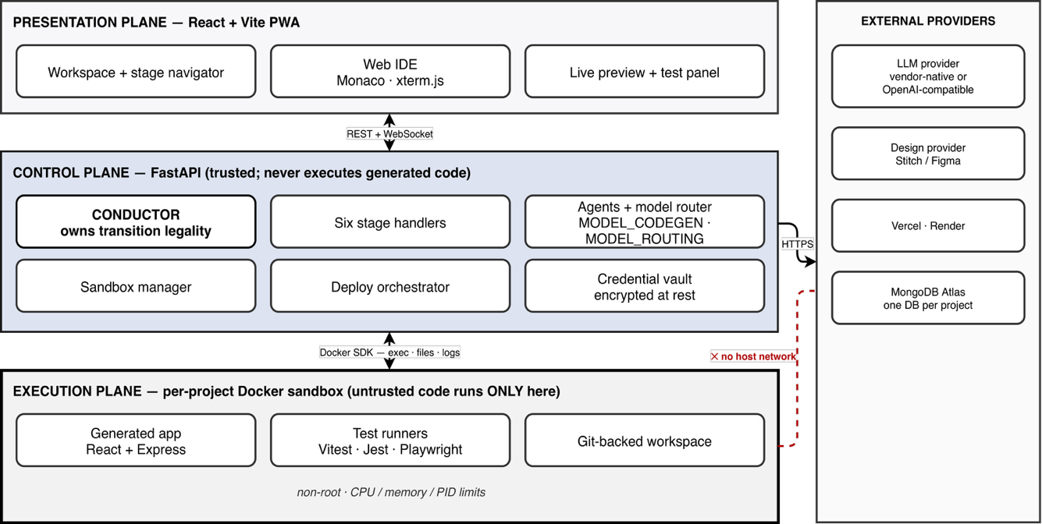
Fig. 1: System architecture with presentation, control and execution planes and external provider boundary. Untrusted code runs only in the per-project sandbox.
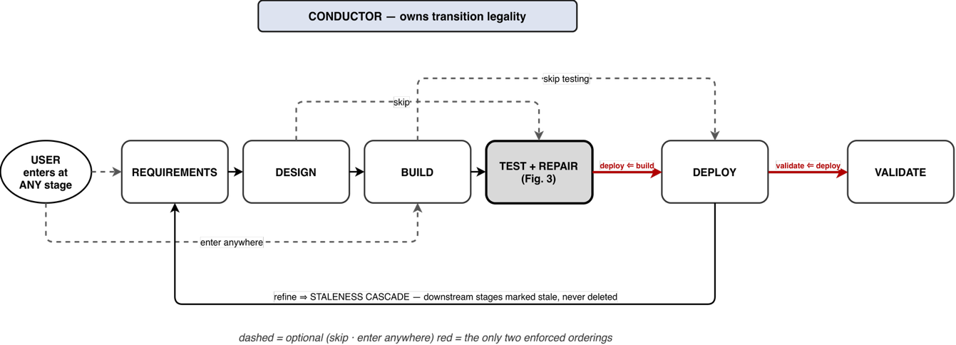
Fig. 2: The non-linear stage model Dashed edges are optional (enter-anywhere, skip); the two bold edges are the only ones that must be ordered; refinement propagates a staleness cascade.
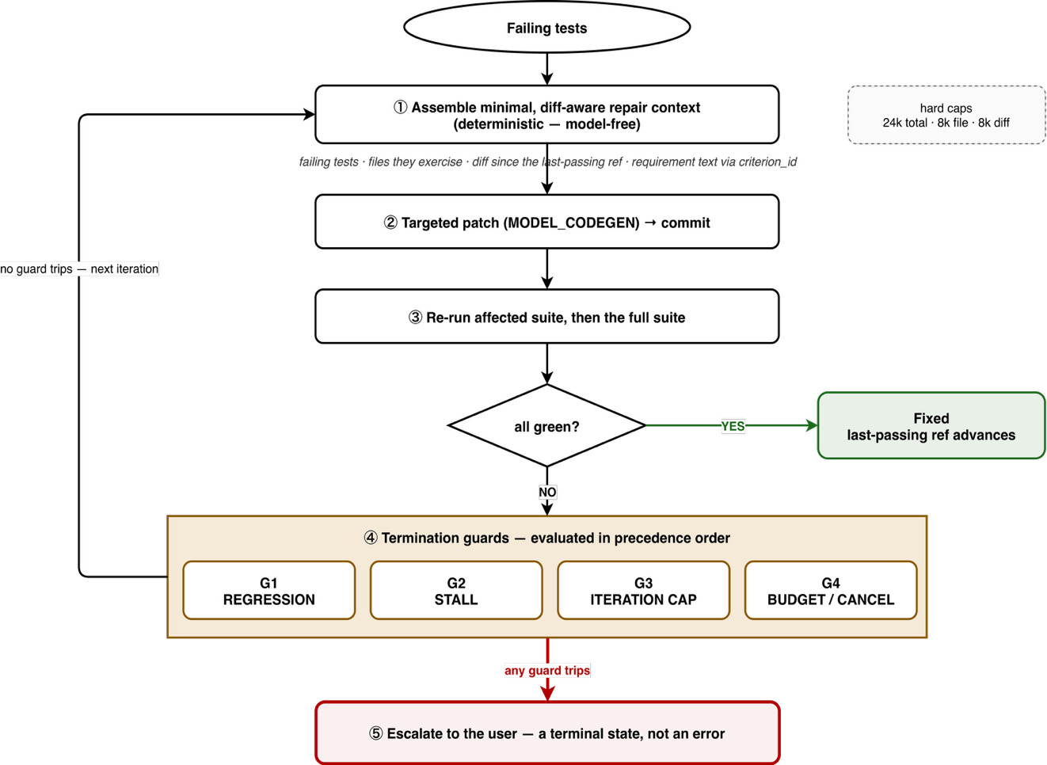
Fig. 3: The bounded, diff-aware repair loop: minimal context assembly, targeted patch, re-execution, four termination guards in precedence order, escalation as a terminal state.
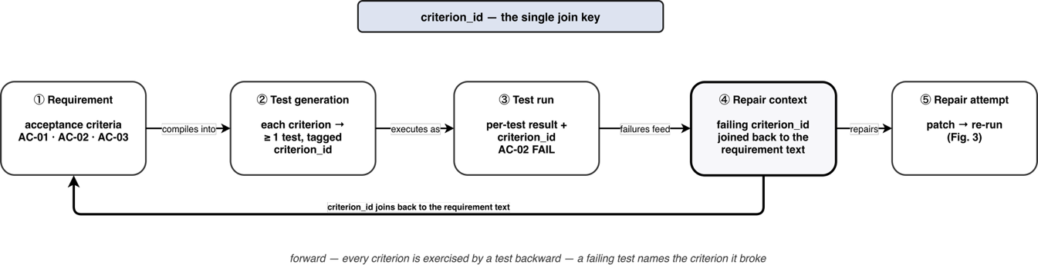
Fig. 4: The traceability chain: One criterion identifier carries an acceptance criterion from test generation to test execution, failure analysis and back to the repair context.
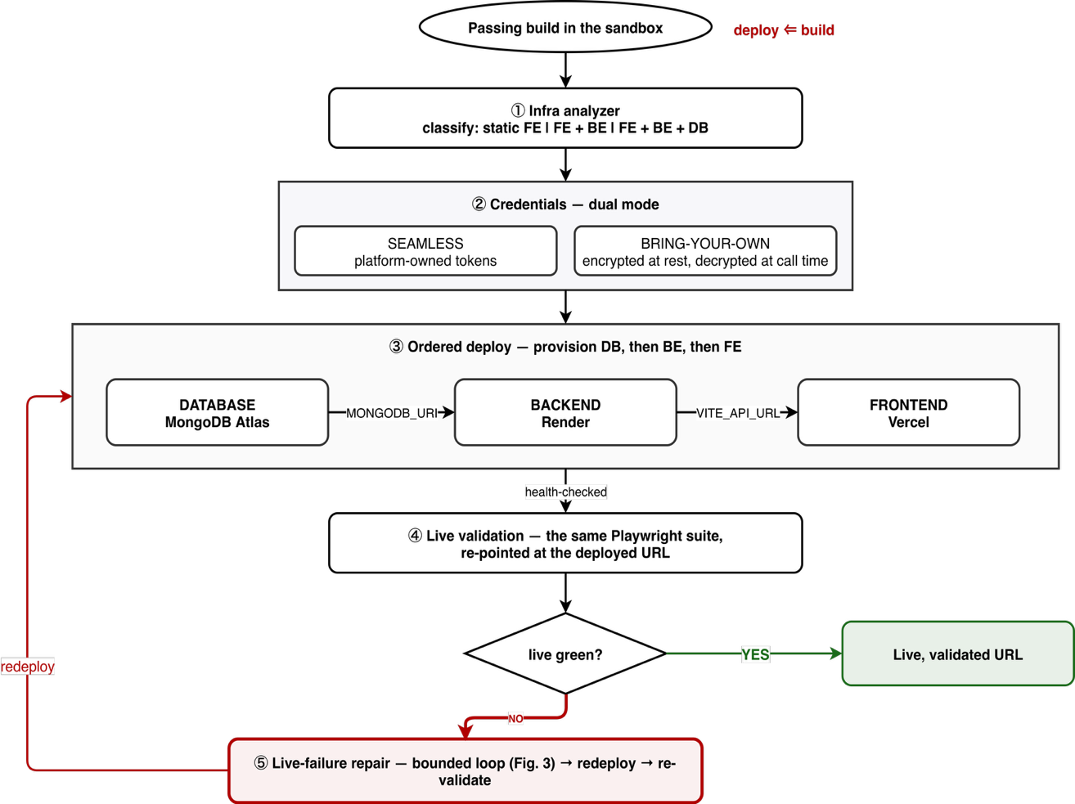
Fig. 5: Infrastructure analysis, dual-mode credentials, the deployment topology, and the post-deployment live-validation and live-failure repair path.
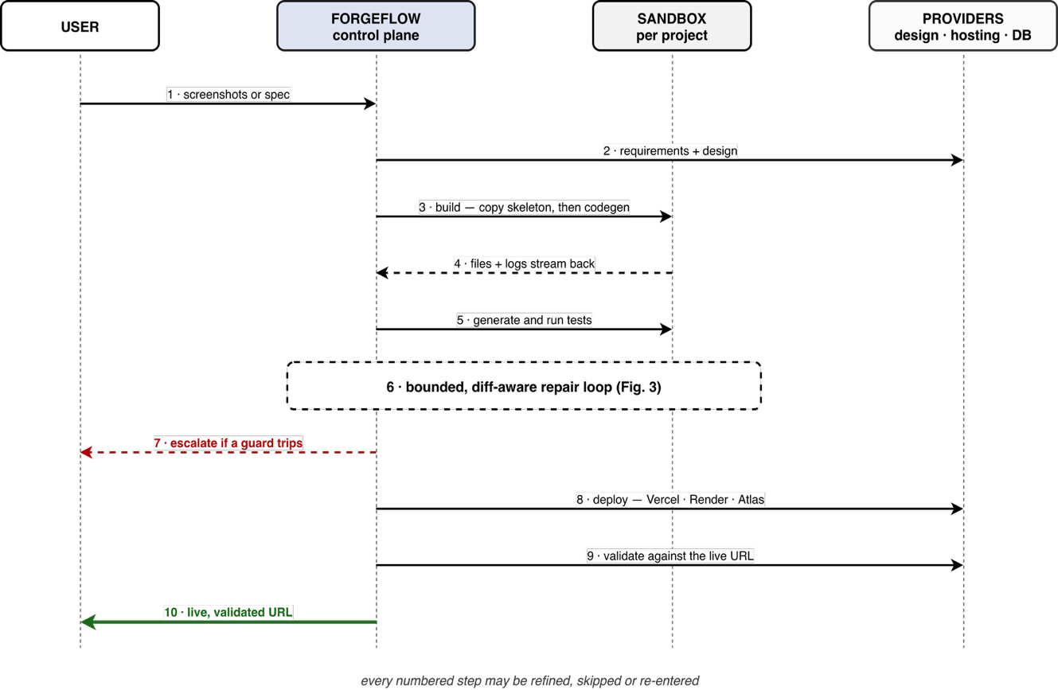
Fig. 6: End-to-end sequence from intake to a live URL, validated against production, each step is refinable, skippable and re-enterable.
(Optional) Please list relevant literature (patent/non-patent) or provide as attachments that help to distinguish the prior art from the invention disclosure
A. Patent literature
Each item is the closest located art for one facet of the invention. Based on the prior-art search conducted to date, the inventors have not identified a reference that discloses the claimed combination of a guard-terminated, diff-aware repair loop with requirement-keyed context coupled with post-deployment live validation.
[P1] US 12,423,062 B1 “AI-based application build and deployment support system and method,” Inswave Systems (2025); closest overall, an LLM assistant that covers project creation, build and deployment. Distinction: Finds suggestions from a database or the web, no iteration-capped controller, no diff-scoped context, no guards, no re-validation of the deployed artefact.
[P2] US 10,956,681 B2 “Creating apps from natural language descriptions,” Google LLC (2021). Distinction: generation and publication only, no test compilation, no repair loop, no non-linear stage model.
[P3] US 2024/0345904 A1 “Automated Error Resolution in a Software Deployment Pipeline,” Dell Products L.P. (2024); NLP matches CI/CD errors to remediation scripts stored in a repository. Distinction: it doesn't select a pre-authored script for a pipeline error, it doesn't define a bounded iteration, it is a synthesised patch from failing application tests.
[P4] US 2017/0228220 A1 “Self-healing automated script-testing tool,” IBM (2016). Distinction: it repairs the application to satisfy the requirement, under a bounded controller, the test is healed to match the application.
[P5] US 11,899,566 B1 (Google LLC, 2024) and US 11,829,282 B2 (Microsoft, 2023), on ML generation of test cases and assertions. Distinction: both get tests from code, but here the tests are compiled from user written acceptance criteria whose identifier remains in the repair context.
[P6] US 9,940,222 B2 “Safety-critical software automated requirements-based test case generation,” General Electric (2018). Distinction: model-based and coverage-driven; neither generate nor repair the application and provides no traceability key for a repair context.
[P7] US 11,645,548 B1 / US 2023/0123077 A1 “Automated cloud data and technology solution delivery using ML and AI modeling,” McKinsey & Co. Distinction: infrastructure-as-code generation without application generation, test-driven repair or post-deployment re-validation.
[P8] US 10,489,126 B2 “Automated code generation,” Oracle (2019) and US 10,360,473 B2 “User interface creation from screenshots.” Distinction: screen shot to UI conversion only – here one pluggable, human-refinable, versioned and skippable stage, not the pipeline.
[P9] US 2024/0020096 A1 “Generating code using language models trained on computer code,” OpenAI OpCo LLC. Distinction: Correctness filtering at function scale, independent sample; no repair controller over an evolving workspace; no termination guards.

B. Non-patent literature
There are five negative empirical results from the literature that motivate claimed elements:
[N1] S. Shukla, H. Joshi, R. Syed, “Security degradation in iterative AI code generation,” Proc. IEEE ISTAS 2025, doi:10.1109/ISTAS65609.2025.11269659: repeated self-refinement can weaken security monotonically. Motivates the iteration cap.
[N2] T. Kiecker et al., “Is three the magic number?” arXiv:2607.05197 (2026); J. J. Arimbur, arXiv:2604.10508 (2026): most attainable gain arrives within one to three iterations. Motivates the cap and stall guard.
[N3] S. Haroon, M. T. Khan, M. A. Gulzar, “Evaluating LLM-based test generation under software evolution,” arXiv:2603.23443 (2026): suites lose validity as code changes because models attend to remembered code. Its recommended highlighted diff is the basis of the moving last-passing reference.
[N4] T. Zhang et al., “Deployability-centric infrastructure-as-code generation,” arXiv:2506.05623 (2025): first-attempt deployment success of 30.2% and 26.8% for two frontier models. Motivates infrastructure classification and live validation.
[N5] N. Tang et al., arXiv:2605.29442 (2026); R. Huang et al., arXiv:2512.14012 (2025); W. Takerngsaksiri et al., “Human-in-the-loop software development agents,” Proc. ICSE-SEIP 2025, doi:10.1109/ICSE-SEIP66354.2025.00036: developer-agent misalignment and deliberate practitioner control. Motivate the non-linear stage model and escalation.
[N6] C. S. Xia et al., “Agentless,” Proc. ACM Softw. Eng. 2(FSE) 2025, doi:10.1145/3715754; I. Bouzenia et al., “RepairAgent,” Proc. ICSE 2025; C. Si et al., “Design2Code,” Proc. NAACL 2025; R. Rabin et al., “SandboxEval,” arXiv:2504.00018 (2025): motivating respectively the deterministic pipeline and copied skeleton, the contrast with unbounded autonomous repair, and the sandbox threat model.
Details of funding (MJRP/MRP or extramural Grant such as CSIR/DST/DBT/ICMR) OR Industry Involvement
The invention was developed without external grant or industry sponsorship. Ownership and entitlement to the invention shall be governed by the applicable institutional Intellectual Property (IP) Policy, inventor agreements, and relevant project or funding guidelines.
Any additional notes or comments?
Nil.

Date: 12 / 09 / 2026 Endorsement by the Director
Place: Pune, Maharashtra, India

